|  |
| --- |
|  |

**FPT UNIVERSITY**

|  |  |
| --- | --- |
| Capstone Project Document | |
| **Application to share equipment and machines between construction sites (houses, bridges and roads)** | |
| Group 7 - IS | |
| **Group members** | Lưu Quang Nghĩa – SE130768 (Leader)  Trương Tổ Kiệt – SE62520  Trần Công Minh – SE62545  Lê Hoàng Nam – SE130765 |
| **Supervisor** | Nguyễn Phan Quang Nhật |
| **Ext. Supervisor** | N/A |
| **Project Code** | CCP |

**– Ho Chi Minh City, January 7th, 2019 –**

**

**CAPSTONE PROJECT REGISTER**

Class: Duration time: from …./…/…. To …/… /…..

(*) Profession: <Software Engineer> Specialty: <ES> <IS> <JS>

X

(*) Kinds of person make registers: Lecturer Students

X

1. Register information for supervisor (if have)

|  |  |  |  |  |
| --- | --- | --- | --- | --- |
|  | **Full name** | **Phone** | **E-Mail** | **Title** |
| Supervisor 1 | Nguyen Phan Quang Nhat |  | Khoa.nguyen@saigontechnology.com | Mr. |

2. Register information for students (if have)

|  |  |  |  |  |  |
| --- | --- | --- | --- | --- | --- |
|  | **Full name** | **Student code** | **Phone** | **E-mail** | **Role in Group** |
| Student 1 |  |  |  |  |  |
| Student 2 |  |  |  |  |  |
| Student 3 |  |  |  |  |  |
| Student 4 |  |  |  |  |  |

3. Register content of Capstone Project

(*) 3.1. Capstone Project name:

English: Application to share equipment and machines between construction sites (houses, bridges and roads)

Vietnamese: Ứng dụng chia sẻ thiết bị giữa các nhà thầu xây dựng (nhà ở, cầu đường)

Abbreviation: **Construction contractor portal**

- **Context**:

* One construction contractor has to hire construction equipment and machinery for drilling, excavators and bulldozers for a period of time. If the construction site is suspended for a period of about 1.2 weeks or actual work is sooner or later than the plan, it may cause losses for the enterprise (because the contract for leasing the equipment and equipment not easy to be changed).

- **Building the system provides following services:**

* Construction contractor with free equipment or machines for a period of time will need to lease the construction sites nearby.
  + Contractor post details of equipment or machines details along with available time, location of the construction site
  + This can be used to share equipment or machines in the same construction company also
* Construction sites need to clean debris, need to find suppliers around
* The nearby sites want to share materials for each other.
  + Contractor post details of material details along with location of the construction site
* Manager of construction sites having requirements on equipment or machines can search for available ones based on filter details.
  + System should allow to manager register filter result, then the system will notify immediately when there is any supplier matching.

(*) 3.2. Main proposal content (including result and product)

1. Theory and practice (document):

* Student should apply the software development process and the UML.
* Software artifacts include User Requirement, Software Requirement Specification,
* Architecture Design, Detail Design, System Implementation and Testing Document,
* Installation Guide, sources code, and deployable software packages.
* 3 tiers should be applied.
* Server side technique:
  + Database design, OOA, OOD, OOP, MVC, Java or .Net technology, …
* Client side technique:
  + HTML5, CSS, JavaScript, JQuery, Ajax, Android, Swift, ...
* Communication technique:
  + Exchange information and transfer data in effective in networks, communicating protocol between mobile devices...
* Research
  + Mobile development; Android, iOS, Hybrid frameworks (React Native, Flutter)
  + Algorithms about finding matching between supply and demand details.

1. Program:

* Web application:
  + For site admin
    - Mange master data
    - Track status and progress of all contractors
  + For contractors
* API for mobile applications
* Mobile Applications

1. Other products:

* All of management functions of the system must be implemented to support the operating system in best.
* Papers.

4. Other comment (propose all relative thing if have)

**N/A**

|  |  |
| --- | --- |
| **Supervisor (If have)**  *(Sign and full name)* | ……………….., date …./…../………….  **On behalf of Registers**  *(Sign and full name)* |

**Table of Contents**

**Table of Contents** 5

A. Introduction 7

1. Project Information 7

2. Introduction 7

3. Current Situation 7

4. Problem Definition 8

5. Proposed Solution 8

5.1. Featured functions 8

5.2. Advantages and disadvantages 9

6. Functional Requirements 10

6.1. Contractor website and mobile application 10

6.2. Admin website 10

7. Role & Responsibility 11

B. Software Project Management Plan 11

1. Software Process Model 11

C. Software Requirement Specification 12

1. User Requirement Specification 12

1.1. System Overview Use Case 13

1.2. List of use case 15

2. Conceptual Diagram 34

D. Software Design Description 36

1. System Architecture Design 36

1.1. Admin web application: 37

1.2. Contractor web system: 37

2. Component Diagram 38

3. Class Diagram 40

4. Interaction Diagram 42

4.1. Contractor Web System 42

4.2. Mobile application 48

4.3. Admin web application 51

5. Database Design 52

5.1. Entity Relationship Diagram (ERD) 52

5.2. Data Dictionary 54

6. Algorithms 55

6.1. Price suggestion model 55

7. Physical Diagram 61

8. Future Plans 62

# Introduction

## Project Information

* Project name: **Application to share equipment and machines between construction sites (houses, bridges and roads)**
* Project Code: **CCP**
* Product Type: **Website Application / Mobile Application**
* Start Date: **January 7th, 2019**
* End Date: **April 27th, 2019**

## Introduction

This document introduces a solution for construction contractors’ equipment sharing. While executing the project of building a construction, contractors have to hire construction equipment and machinery for drilling, excavators and bulldozers for a period of time. However, if there is a gap between project plan and the actual work, the unused equipment will cause loss to the enterprise.

We build a system to assist companies to resolve this problem, which is called Construction Contractor Portal. The system operates like a platform for contractors to share their equipment, helps finding, managing and providing useful information for the entire hiring process. The system also provides a common ground for construction materials and debris service.

This document also describes our working process in 4 months including our perspective on the system, component design and detailed core workflows. We hope our solution would be widely applied and somehow enhance the development of our country.

## Current Situation

When a contractor needs to lease construction equipment to another contractor, they usually depend on their current network and relationships. They would use available yet not dedicated communication channels including direct communication or via social network. When the information reaches to the right contractor and the equipment is still available, both sides have to use their own available systems, or create a new one, in order to manage the delivery process, equipment status, transaction history.

This situation is similar to the case when a contractor needs to find equipment for rent from other contractors. They rely only on current relationship network and traditional communication channels. These channels consume large amount of time and effort which is luxury for busy contractors.

## Problem Definition

Below are disadvantages of current situation:

* **Taking too much time causing lost for the company**. Because the contractor heavily depends on their personal network, the information spread slowly and narrowly within normal communication channels until it reaches the right contractor. During the long searching time, the equipment is left unused and wasted.
* **Difficult searching method.** With traditional approach, the contractor has to manually search for equipment, which takes too much time and effort, causing frustration and bad user experience
* **Hard to manage.** The contractors have to use their own management system, if not creating a new one, to manage the equipment during the renting process. This personal management system may not be specialized for equipment renting and unsynchronized between related contractors.

## Proposed Solution

Our proposed solution is to build a system called Construction Contractor Portal (CCP) to resolve the current situation by providing a common ground for contractors to hire and lease construction equipment. This system supports contractors to send their request and execute equipment renting transactions more easily. The CCP system includes two web application and a mobile application with the following functions

### Featured functions

* Administrator system (Web application):
  + **Manage contractors**: Admin or staff can manage, adjust information of contractors with high authority actions
  + **Verify information**: Admin or staff can check and verify and sensitive information, contractor profile information, bad behavior reports.
  + **Manage overall system**: Admin can view overall statistics of contractor system, define and manage fundamental data type such as equipment types, material types, etc.
* Client applications (Web application and mobile application):
  + **Connect contractors with equipment-renting related needs**: Contractors who have equipment for rent can post information onto the system. Contractors who in need of renting equipment can search and find the right kind of equipment required. When the two sides find their targets, they can contact each other and make the final decision whether to rent the equipment or not.
  + **Manage hiring process:** When agreement has been made between the supplier and requester, they can get information about the delivery process and renting equipment status
  + **Manage equipment:** Contractor can manage and adjust information about the equipment that posted to the system
  + **Material ordering**: Contractor can set materials for sale, search for material, buy materials and manage material delivery process.
  + **Debris service**: The system connects suppliers and requesters with debris related needs. Contractors can require debris service, offer and bid for debris services, and manage debris transactions.
  + **Notifications:** The contractor can get notifications about critical information related to equipment and renting process. The contractor can also subscribe for specific types of equipment and get related notifications in the future.

### Advantages and disadvantages

The advantages and disadvantages of the proposed solution:

* Advantages
  + **Better market for equipment renting:** The system provides a more appropriate, dedicated and exclusive connection network for equipment renting demand. Contractors no longer need to rely on personal connection and regular communication channels. They would know exactly where to go to when thinking about equipment renting.
  + **Save time and effort for searching:** Contractors can save time and effort in searching for equipment easily with automatic tools instead of manual methods.
  + **Centralized management:** Managing all information including renting process, equipment information, other contractor’s profile, in one place, leading to better management and decision making.
* Disadvantages:
  + **Can not satisfy all demands:** Business is a very flexible and complicated field and there are special business cases that the system cannot fit. Staff involvement may be required in order to resolve these special situations.

## Functional Requirements

Function requirements of the system are listed as below:

### Contractor website and mobile application

* Contractor can search for construction equipment with filter and sorting
* Contractor can manage equipment to the system
* Contractor can manage and change their equipment status
* Contractor can request to hire equipment, manage delivery process, send feedback for each transaction
* Contractor can add and manage construction locations for future reuse
* Contractor can manage, send order to materials
* Contractor can manage materials transactions
* Contractor can publish requirement for debris service
* Contractor can search and bid his offer on a debris service
* Contractor can manage debris transaction and process
* Contractor can send feedback after each transaction including hiring transaction, material transaction, debris transaction
* Contractor can manage their profile information
* Notification about important information would be sent to contractors
* Contractor can subscribe an equipment type and receive future notifications when new equipment of that type is posted
* System can suggest contractor the proper price for the equipment while posting
* Contractor can report other contractor for bad behaviors, which would be reviewed by staff

### Admin website

* Admin can manage equipment types, material types, debris service types
* Admin can manage and define additional specs fields for each equipment type
* Admin can manage staff accounts
* Staff can manage, activate, deactivate, verify contractor accounts and profile
* Staff can view and verify reports about bad behavior
* Staff can edit information related to equipment transaction, materials transaction and debris transaction with high authority
* Staff can view overall statistics about contractor system.
* Staff can send custom notifications to a specific contractor

## Role & Responsibility

|  |  |  |  |  |
| --- | --- | --- | --- | --- |
| **No** | **Full Name** | **Role** | **Position** | **Contact** |
| 1 | Nguyễn Phan Quang Nhật | Project Manager | Supervisor | nhat.nguyen@saigontechnology.com |
| 2 | Lưu Quang Nghĩa | Developer | Leader | nghialqse130768@fpt.edu.vn |
| 3 | Trương Tổ Kiệt | Developer | Member | kietttse62520@fpt.edu.vn |
| 4 | Trần Công Minh | Developer | Member | minhtcse62545@fpt.edu.vn |
| 5 | Lê Hoàng Nam | Developer | Member | namlhse130765@fpt.edu.vn |

**Table 1 : Roles and Responsibilities**

# Software Project Management Plan

## Software Process Model

This project is developed using Scrum model – part of an agile framework for Software development project. Scrum model is chosen because of the following reasons:

* Scrum is the most suitable model for small and medium project, and we only have 4 members
* The term “machine learning” is new to the team and there would be many trial-and-error tests with the system design before applying to the official release
* There are many new technologies that team members have to learn and develop at the same time, so SCRUM would allow us to do that
* The business model may not be fully tested in real market condition so changes are highly possible. Using Scrum team members can adapt to changes better

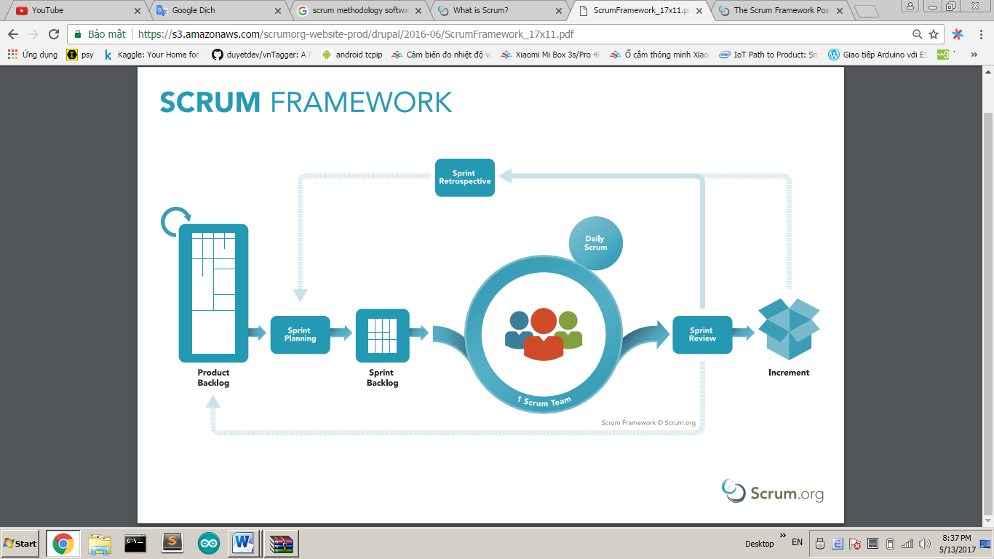

Figure 1 - Scrum Framework

# Software Requirement Specification

## User Requirement Specification

### System Overview Use Case

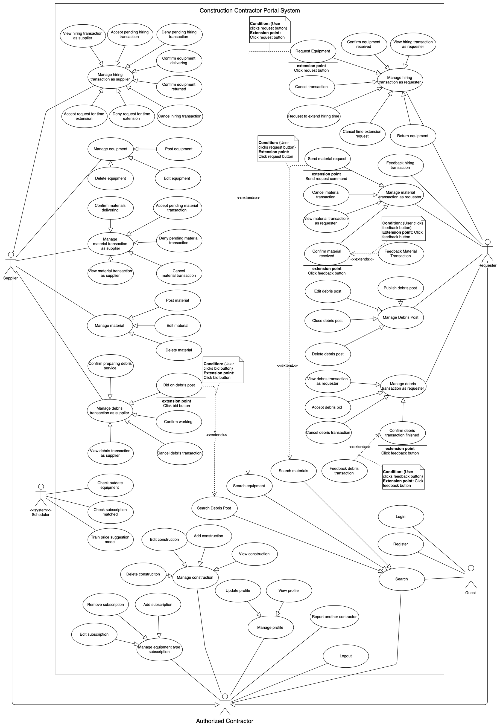

Figure 2 Contractor Portal System Overview Use case Diagram

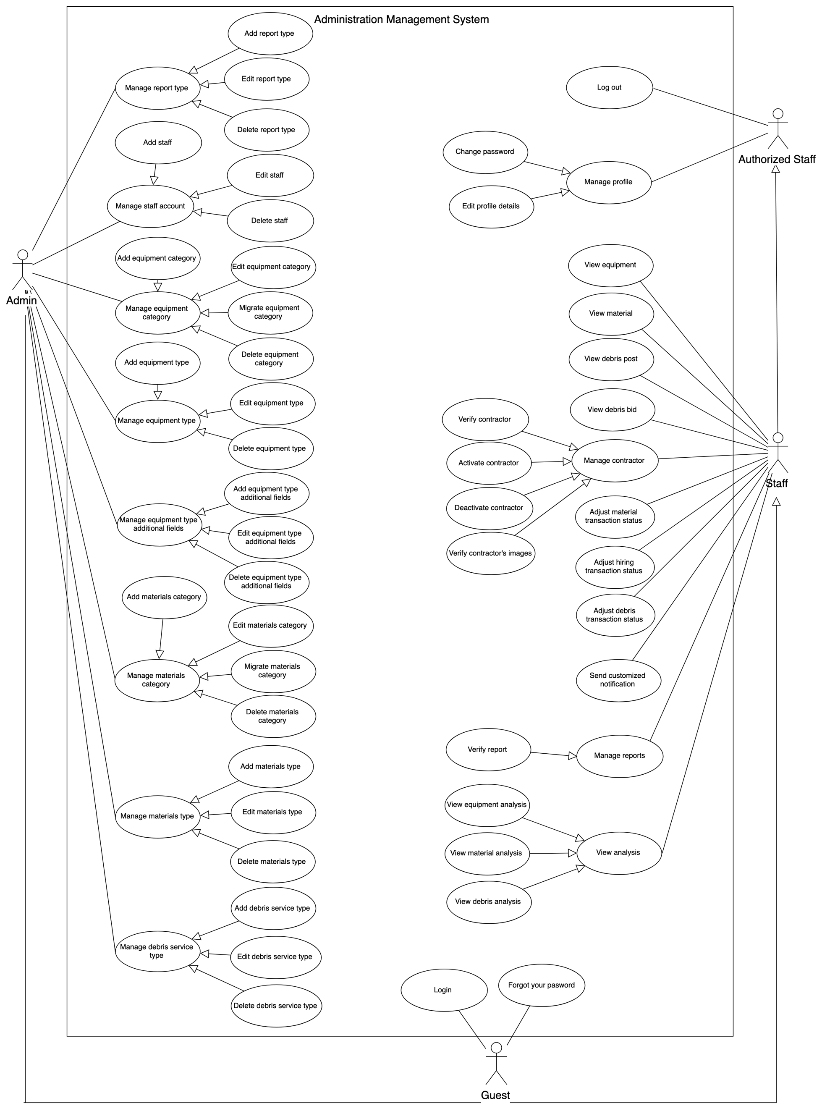

Figure 3 Administration Management System Overview Use case Diagram

### List of use case

#### <Supplier> Overview Use Case

##### <Supplier> Post equipment

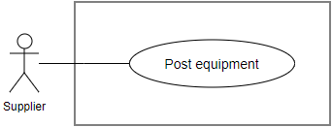

Figure 29: <Supplier> Post equipment Use Case Specification

|  |  |  |  |
| --- | --- | --- | --- |
| **USE CASE – CCP_UC_26** | | | |
| **Use Case No.** | **CCP_UC_26** | **Use Case Version** | 1.1 |
| **Use Case Name** | Post equipment | | |
| **Author** | Luu Quang Nghia | | |
| **Date** | 19/3/2018 | **Priority** | High |
| **Actor:**   * Supplier   **Summary:**   * This use case allows supplier to post new equipment   **Goal:**   * Supplier can post new equipment   **Triggers:**   * Supplier send command to post new equipment   **Preconditions:**   * User must login to the system * Account of user must be activated   **Post conditions:**   * Success: New equipment is posted * Fail: Show error message   **Main Success Scenario:**   |  |  |  | | --- | --- | --- | | **Step** | **Actor Action** | **System Response** | | 1 | User go to new equipment view | System requires information about the equipment:   * Name: free text input, required, length 3-80 * Images: image, required, quantity: at least 1 * Thumbnail image: image, required, quantity: 1 * Construction: required * Equipment type: select from options list * Additional information related to selected equipment type * Price per day: number text input, required * Available time ranges * Description: free text input, length: 0- 1000 | | 2 | User input information |  | | 3 | User send command to create new equipment | System validate information, display request for confirmation | | 4 | User confirm the action  [Alternative 1] | System display successful message  [Exception 1] |   **Alternative Scenario:**   |  |  |  | | --- | --- | --- | | **No** | **Actor Action** | **System Response** | | 1 | User choose not to confirm the action | System hides the message and go back to inputting view |   **Exceptions:**   |  |  |  | | --- | --- | --- | | **No** | **Cause** | **System Response** | | 1 | No internet connection | System shows message the "Please check your connection" when the internet is lost. | | 2 | User input invalidate information. | System show error message for the input mistake |   **Relationships:** N/A  **Business Rules:**   * Posted equipment would have default status “Available” * Images are uploaded from user’s device * Thumbnail images are chosen from uploaded image list * Construction can be used as location information * Each construction has information about construction name and location * User can choose to create new construction or select from created constructions * Each available time range is the time duration that the equipment is available for rent * Each available time range includes a beginning date and an ending date * Each equipment can have multiple time ranges, which does not intersect each other * Requester can only request hiring time that included between available time range * Each equipment type has its own additional attributes * After supplier post new equipment successfully, other requester can find and view the new equipment * In some special real-life business cases, user can group multiple equipment into 1 post, to manage the whole group as a single equipment with a single status | | | |

Table 2 <Supplier> Post Equipment Use case specification

##### <Supplier> Post material

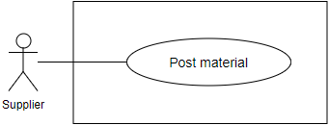

**Use Case Specification**

|  |  |  |  |
| --- | --- | --- | --- |
| **USE CASE – CCP_UC_29** | | | |
| **Use Case No.** | **CCP_UC_29** | **Use Case Version** | 1.1 |
| **Use Case Name** | Post material | | |
| **Author** | Luu Quang Nghia | | |
| **Date** | 19/3/2018 | **Priority** | High |
| **Actor:**   * Supplier   **Summary:**   * This use case allows supplier to post new material   **Goal:**   * Supplier can post new material   **Triggers:**   * Supplier send command to post new material   **Preconditions:**   * User must login to the system * Account of user must be activated   **Post conditions:**   * Success: New material is posted * Fail: Show error message   **Main Success Scenario:**   |  |  |  | | --- | --- | --- | | **Step** | **Actor Action** | **System Response** | | 1 | User go to the new material view | System requires information about the material:   * Name: text input, required, length 3-80 * Thumbnail image: image input, required, quantity: 1 * Manufacturer: text input, required * Construction: required * Material type: select from options list * Price per unit: number text input, required * Description: free text input, length: 0- 1000 | | 2 | User input information |  | | 3 | User send command to create new material | System validate information, display request for confirmation | | 4 | User confirm the action  [Alternative 1] | System display a successful message  [Exception 1] |   **Alternative Scenario:**   |  |  |  | | --- | --- | --- | | **No** | **Actor Action** | **System Response** | | 1 | User choose not to confirm the action | System hides the message and go back to inputting view |   **Exceptions:**   |  |  |  | | --- | --- | --- | | **No** | **Cause** | **System Response** | | 1 | No internet connection | System shows message the "Please check your connection" when the internet is lost. | | 2 | User input invalidate information. | System show error message for the input mistake |   **Relationships:** N/A  **Business Rules:**   1. Material unit information is based on chosen material type 2. Construction can be used as location information 3. Each construction has information about construction name and location 4. User can choose to create new construction or select from created constructions 5. After supplier post new material successfully, other requester can search and view the new material | | | |

Table 3 <Supplier> Post material Use case specification

##### <Supplier> Bid on debris post

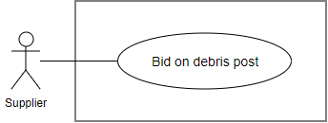

Figure 41: <Supplier>Bid on debris post

**Use Case Specification**

|  |  |  |  |
| --- | --- | --- | --- |
| **USE CASE – CCP_UC_38** | | | |
| **Use Case No.** | **CCP_UC_38** | **Use Case Version** | 1.1 |
| **Use Case Name** | Bid on debris post | | |
| **Author** | Luu Quang Nghia | | |
| **Date** | 18/3/2018 | **Priority** | High |
| **Actor:**   * Supplier   **Summary:**   * This use case allow supplier to bid on a debris post   **Goal:**   * Supplier can bid on debris post   **Triggers:**   * Supplier send command to bid on debris post   **Preconditions:**   * User must login to the system * Account of user must be activated * Debris post status is “Pending”   **Post conditions:**   * Success: Supplier successfully bid on debris post * Fail: Show error message   **Main Success Scenario:**   |  |  |  | | --- | --- | --- | | **Step** | **Actor Action** | **System Response** | | 1 | User viewing debris post details and send command to bid on debris bid | System require the following information from user:   * Price: double, required * Description: text, required | | 2 | User provide required input |  | | 3 | User sends the command to create bid on debris post | System validates information  If validated, system ask user for confirmation [Exception 1, 2] | | 4 | User send command to confirm the request  [Alternative 1] | System shows message that request have made successfully, waiting for supplier’s acceptance |   **Alternative Scenario:**   |  |  |  | | --- | --- | --- | | **No** | **Actor Action** | **System Response** | | 1 | User send command to unconfirm the request | System back to the making request view |   **Exceptions:**   |  |  |  | | --- | --- | --- | | **No** | **Cause** | **System Response** | | 1 | No internet connection | System shows message the "Please check your connection" when the internet is lost. | | 2 | User send command to create new request | System shows error message show that input date is not available and ask user to input again |   **Relationships:** N/A  **Business Rules:**   * Debris bid can be understood as a service proposal, with a price, according to the requester’s requirement. * Supplier can view debris post details before place a bid with the following information:   + Debris post’s title   + Debris post’s image   + Debris post’s description   + Debris post’s services required   + Requester’s profile   + Requester’s phone number * Supplier can view other bids placed on the debris post, each bid has the following information:   + Price   + Description   + The supplier’s profile   + A bid can have the following status:   + Pending: supplier bid on a post and waiting for requester to choose   + Accepted: Requester chose the bid and created a debris transaction   + Finished: Debris transaction is finished * A bid is created with status “Pending”. * Requester is notified about the bid. * Each bid is related to only 1 debris post. * A supplier can only place 1 bid on 1 debris post. * Supplier can only bid on “Pending” post. * If the request is made successfully, system notify supplier about the request . | | | |

Table 4 <Supplier> Bid on debris post Use case specification

#### <Requester> Overview Use Case

##### <Requester> Request equipment

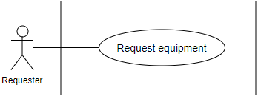

Figure 48: <Requester>Request equipment

**Use Case Specification**

|  |  |  |  |
| --- | --- | --- | --- |
| **USE CASE – CCP_UC_44** | | | |
| **Use Case No.** | **CCP_UC_44** | **Use Case Version** | 1.1 |
| **Use Case Name** | Request equipment | | |
| **Author** | Luu Quang Nghia | | |
| **Date** | 18/3/2018 | **Priority** | High |
| **Actor:**   * Requester   **Summary:**   * This use case allow requester to request equipment for material   **Goal:**   * Requester request equipment   **Triggers:**   * Requester send the command to view equipment details   **Preconditions:**   * User must login to the system * Account of user must be activated * Equipment status must be available   **Post conditions:**   * Success: The new request is composed * Fail: Show error message   **Main Success Scenario:**   |  |  |  | | --- | --- | --- | | **Step** | **Actor Action** | **System Response** | | 1 | User viewing equipment details | System require the following information from user:   * Begin material date * End material date * Address | | 2 | User provide the correct information |  | | 3 | User send the command to create new request | System validates information  If validated, system ask user for confirmation [Exception 1, 2] | | 4 | User send command to confirm the request  [Alternative 1] | System shows message that request have made successfully, waiting for supplier’s acceptance |   **Alternative Scenario:**   |  |  |  | | --- | --- | --- | | **No** | **Actor Action** | **System Response** | | 1 | User send command to unconfirm the request | System back to the making request view |   **Exceptions:**   |  |  |  | | --- | --- | --- | | **No** | **Cause** | **System Response** | | 1 | No internet connection | System shows message the "Please check your connection" when the internet is lost. | | 2 | User send command to create new request | System shows error message show that input date is not available and ask user to input again |   **Relationships:** N/A  **Business Rules:**   * The request can be understood as a “Pending” transaction * Each request is related to only one equipment * Time range means the time from beginning date to ending date * Time range’s unit is date (not hour nor month) * User can choose to use construction’s location as equipment’s location * User can view at least the following information before making request:   + Equipment name, price, images, description type   + Distance from supplier’s equipment to requester’s construction   + Price calculated based on input time range and daily price   + Available time range of equipment   + Supplier’s profile   + Supplier’s phone number * When user change beginning date, ending date, or construction/location, the price change accordingly. * System validate user’s input for the following criteria:   + The requested time range is “contained” in the equipment’s available time range   + There are no “Accepted” or “Processing” transaction with time range intersecting with the requested time range * If the request is made successfully, system notify supplier about the request. | | | |

Table 5 <Requester> Request equipment Use case specification

##### <Requester> Request to extend hiring time

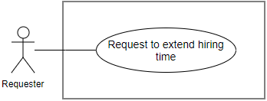

Figure 50: <Requester>Request to extend hiring time

**Use Case Specification**

|  |  |  |  |
| --- | --- | --- | --- |
| **USE CASE – CCP_UC_46** | | | |
| **Use Case No.** | **CCP_UC_46** | **Use Case Version** | 1.0 |
| **Use Case Name** | Request to extend hiring time | | |
| **Author** | Luu Quang Nghia | | |
| **Date** | 18/3/2018 | **Priority** | High |
| **Actor:**   * Requester   **Summary:**   * This use case allows requester to send request for extend equipment hiring time   **Goal:**   * Requester send request for extending equipment hiring time to the supplier   **Triggers:**   * Requester send command to make request for extending equipment hiring time   **Preconditions:**   * User must login to the system * There’s no other pending request for hiring time extension * The transaction status is “Accepted” or “Processing”   **Post conditions:**   * Success: Requester send request to extend equipment hiring time * Fail: Show error message   **Main Success Scenario:**   |  |  |  | | --- | --- | --- | | **Step** | **Actor Action** | **System Response** | | 1 | User send command to extend hiring request | System requires user to input extended end date | | 2 | User input required information |  | | 3 | User send command to make the request | Systems validate user input for the following criteria:   * The extended time range must be in between available time range * Extended end date must be after the current date * Extended end date must be after the current end date   If input validated, system ask user to confirm the request  [Exception 1, 2] | | 4 | User confirm the request  [Alternative 1] | System show message that the request has been sent successfully  [Exception 1] |   **Alternative Scenario:**   |  |  |  | | --- | --- | --- | | **No** | **Actor Action** | **System Response** | | 1 | User choose not to confirm | System back to the making-requests view |   **Exceptions:**   |  |  |  | | --- | --- | --- | | **No** | **Cause** | **System Response** | | 1 | No internet connection | System shows message the "Please check your connection" when the internet is lost. | | 2 | User send command to make the request | Input not validated, system show error to user |   **Relationships:** N/A  **Business Rules:**   * Requester cannot extend the beginning date when the transaction status is other than “Accepted” or “Processing” * If requester want to extend hiring time of a “Pending” transaction, he must cancel it and make a new “Pending” transaction * Time range means the time from beginning date to ending date * Time range’s unit is date (not hour nor month) * Extended time range has the following information:   + Begin date: current transaction’s begin date   + End date: input by user * The extended time range must wider than the current time range. * The extended time range is “contained” in the equipment’s available time range. * There are no “accepted” or “processing” transaction that intersect with the extended time range * The supplier is notified about the request * The sent request has status “Pending” * There are only 1 “Pending” time extension request at a time * Requester can review the request later | | | |

Table 6 <Requester> Request to extend hiring time Use case specification

##### <Requester> Send material request

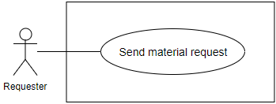

Figure 55: <Requester>Send material request

**Use Case Specification**

|  |  |  |  |
| --- | --- | --- | --- |
| **USE CASE – CCP_UC_51** | | | |
| **Use Case No.** | **CCP_UC_51** | **Use Case Version** | 1.1 |
| **Use Case Name** | Send material request | | |
| **Author** | Luu Quang Nghia | | |
| **Date** | 11/4/2018 | **Priority** | High |
| **Actor:**   * Requester   **Summary:**   * This use case allow requester to send material request   **Goal:**   * Requester request material   **Triggers:**   * Requester send the command to request materials   **Preconditions:**   * User must login to the system * Account of user must be activated   **Post conditions:**   * Success: The new request is sent * Fail: Show error message   **Main Success Scenario:**   |  |  |  | | --- | --- | --- | | **Step** | **Actor Action** | **System Response** | | 1 | User create new request | System require the following information from user:   * Address: text, required * Materials: entity, required * Quantity of each material: double, required | | 2 | User provide the correct information |  | | 3 | User send the command to create new request | System validates information  If validated, system ask user for confirmation [Exception 1, 2] | | 4 | User send command to confirm the request  [Alternative 1] | System shows message that request have made successfully, waiting for supplier’s acceptance |   **Alternative Scenario:**   |  |  |  | | --- | --- | --- | | **No** | **Actor Action** | **System Response** | | 1 | User send command to unconfirm the request | System back to the making request view |   **Exceptions:**   |  |  |  | | --- | --- | --- | | **No** | **Cause** | **System Response** | | 1 | No internet connection | System shows message the "Please check your connection" when the internet is lost. | | 2 | User send command to create new request | System shows error message show that input date is not available and ask user to input again |   **Relationships:** N/A  **Business Rules:**   * The request can be understood as a “Pending” transaction * Request material means create a new “Pending” material transaction * Each material transaction can include multiple materials, which can be understood as “material details” * User can choose multiple materials and checkout at once. * Materials in a transaction must belong to the same supplier * Server must separate checked-out materials into multiple transaction so that each material in the same transaction must belong to the same supplier * User can view at least the following information before making request:   + Material name, unit, image, description, manufacturer, price   + Total price calculated based quantity and cost of material   + Supplier’s profile   + Supplier’s phone number * System get longitude, latitude information based on provided address. * The information in the transaction, except status, cannot be modified in anyway, including price, receiving address. * If the request is made successfully, system notify supplier about the request. | | | |

Table 7 <Requester> Send material request Use case specification

##### <Requester> Publish debris post

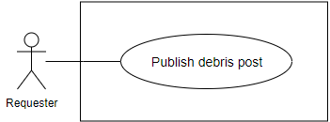

Figure 59: <Requester>Publish debris post

**Use Case Specification**

|  |  |  |  |
| --- | --- | --- | --- |
| **USE CASE – CCP_UC_55** | | | |
| **Use Case No.** | **CCP_UC_55** | **Use Case Version** | 1.1 |
| **Use Case Name** | Publish debris post | | |
| **Author** | Tran Cong Minh | | |
| **Date** | 19/3/2018 | **Priority** | High |
| **Actor:**   * Requester   **Summary:**   * This use case allows requester to publish a debris post   **Goal:**   * Requester can publish a debris post   **Triggers:**   * Requester send command to publish a debris post   **Preconditions:**   * User must login to the system * Account of user must be activated   **Post conditions:**   * Success: New debris post is published * Fail: Show error message   **Main Success Scenario:**   |  |  |  | | --- | --- | --- | | **Step** | **Actor Action** | **System Response** | | 1 | User send command to publish a debris post | System requires information about the debris post:   * Title: free text input, required, length < 1000 * Additional images: image, required, quantity: at least 1 * Thumbnail image: image, required, quantity: 1 * Construction: choose from construction list, required * Debris service type: select from options list, multiple choices allowed * Description: free text input, length: 0- 1000 | | 2 | User input information |  | | 3 | User send command to create new debris post | System validate information, display request for confirmation | | 4 | User confirm the action  [Alternative 1] | System display successful message  [Exception 1] |   **Alternative Scenario:**   |  |  |  | | --- | --- | --- | | **No** | **Actor Action** | **System Response** | | 1 | User choose not to confirm the action | System hides the message and go back to inputting view |   **Exceptions:**   |  |  |  | | --- | --- | --- | | **No** | **Cause** | **System Response** | | 1 | No internet connection | System shows message the "Please check your connection" when the internet is lost. | | 2 | User input invalidate information. | System show error message for the input invalidation |   **Relationships:** N/A  **Business Rules:**   * A debris post can be understood as a job description or requirement for supplier to read before offer debris services and price * Images are uploaded from user’s device * Thumbnail images are chosen from uploaded image list * Debris service type is the type of service required for supplier to offer * Each debris post can have multiple debris service types * Posted debris post would have default status “Pending” * Construction can be used as location information * Each construction has information about construction name and location * User can choose to create new construction or select from created constructions * After requester publish the debris post successfully, other requester can find and view the debris post * In real-life business cases, a debris post is not required to be fully described. It’s supplier’s duty to contact and gather sufficient information before offer the service. | | | |

Table 8 <Requester> Publish debris post Use case specification

#### <Scheduler> Overview Use Case

##### <Scheduler> Check subscription matched

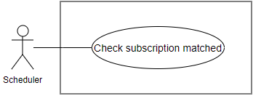

Figure 70: <Scheduler>Check subscription matched

**Use Case Specification**

|  |  |  |  |
| --- | --- | --- | --- |
| **USE CASE – CCP_UC_65** | | | |
| **Use Case No.** | **CCP_UC_65** | **Use Case Version** | 1.0 |
| **Use Case Name** | Check subscription matched | | |
| **Author** | Luu Quang Nghia | | |
| **Date** | 18/1/2018 | **Priority** | Normal |
| **Actor:**   * Scheduler   **Summary:**   * Scheduler check if any equipment matched subscribed conditions   **Goal:**   * Check if any equipment matched subscribed conditions   **Triggers:**   * After every fixed time   **Preconditions:**   * There is at least 1 subscription in the system   **Post conditions:**   * Success: Found matched equipment * Fail: No matched equipment found.   **Main Success Scenario:**   |  |  |  | | --- | --- | --- | | **Step** | **Actor Action** | **System Response** | | 1 | Scheduler send command to check to an equipment when:   * New equipment is posted * Equipment is edited * Transaction time range is updated | System check the equipment based on the required conditions on:   * Available time range * Equipment type * Max price * Max distance | | 2 |  | If the equipment satisfies all the required conditions, notify the subscriber about the equipment  [Alternative 1]  [Exception 1] |   **Alternative Scenario:**   |  |  |  | | --- | --- | --- | | **No** | **Actor Action** | **System Response** | | 1 |  | If the equipment does not satisfy the required conditions, no notification is sent |   **Exceptions:**   |  |  |  | | --- | --- | --- | | **No** | **Cause** | **System Response** | | 1 | Account of user is not activated | System cancel the notifying command and unsubscribe the subscriber |   **Relationships:** N/A  **Business Rules:**   * Subscription can be understood as a requirement for the system to find matched equipment in the future * If the subscriber account is not activated, no notification sent * Notification content must include found equipment information | | | |

Table 9 <Scheduler> Check subscription matched Use case specification

##### <Scheduler> Train price suggestion model

|  |  |  |  |
| --- | --- | --- | --- |
| **USE CASE – CCP_UC_109** | | | |
| **Use Case No.** | **CCP_UC_109** | **Use Case Version** | 1.0 |
| **Use Case Name** | Train price suggestion model | | |
| **Author** | Luu Quang Nghia | | |
| **Date** | 18/1/2018 | **Priority** | Normal |
| **Actor:**   * Scheduler   **Summary:**   * Scheduler collect data and train machine learning model for price suggestion   **Goal:**   * Scheduler train price suggestion model   **Triggers:**   * After every fixed time   **Preconditions:**   * There are fresh data available to train   **Post conditions:**   * Success: New price suggestion weight is generated * Fail: Log error message in the system   **Main Success Scenario:**   |  |  |  | | --- | --- | --- | | Step | Actor Action | System Response | | 1 | Scheduler send command to start model training process | Display in log file: “Model training process started” | | 2 | Scheduler retrieve necessary data batch from database for each equipment type | Display in log file “Data collected”  [Alternative 1]  [Exception 1] | | 3 | Scheduler use collected data to train suggestion model | Display in log file “Data trained successfully” | | 4 | Scheduler save newly trained model to database | Price suggestion model is inserted to database  Information about training process is logged directly to database, including:   * Training time * Validation rate of the model * Each specific weight value of the model * Equipment type related to each weight * Equipment additional specs field related to the model * The time duration in which the data belonged to |   **Alternative Scenario:**   |  |  |  | | --- | --- | --- | | No | Actor Action | System Response | | 1 | Scheduler retrieve data which is not available at the time | Display in log file “The equipment type id = {id} is not calculable” with {id} is the equipment type’s id  Skip to the next equipment type |   **Exceptions:**   |  |  |  | | --- | --- | --- | | No | Cause | System Response | | 1 | Data format is not correct | Display error and stack trace in log file  Skip to the next equipment type | | 2 | Unknown exception throwed | Display error and stack trace in log file  Skip to the next equipment type |   **Relationships**: **CCP_UC_28**  **Business** **Rules**:   * Training data is collected directly from the system * The training data is extracted from equipment data in the system, for specific:   + Equipment price   + Equipment additional specs value with Integer or Double datatype   + Equipment additional specs field related to the value   + Equipment type * The time duration in which the data is collected is 6 months from the current date * The trained model result can be used for later price suggestion calculating * The extracted data is not validated if:   + There are no addition specs fields of the equipment type have the numeric datatype (Integer or Double)   + The data value does not match the defined data type, for example, Integer datatype with value of “abc” | | | |

Table 10 <Scheduler> Train price suggestion model Use case specification

#### <Staff> Overview Use Case

##### <Staff> Verify contractor

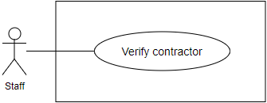

Figure 72: <Staff>Verify contractor

**Use Case Specification**

|  |  |  |  |
| --- | --- | --- | --- |
| USE CASE – CCP_UC_66 | | | |
| Use Case No. | CCP_UC_66 | Use Case Version | 1.1 |
| Use Case Name | Verify contractor | | |
| Author | Truong To Kiet | | |
| Date | 18/1/2018 | Priority | Normal |
| Actor:   * Staff   Summary:   * This use case allows staff to verify contractor.   Goal:   * Staff change contractor status from “Not verified” to “Activated”.   Triggers:   * Staff send verify contractor command to the system.   Preconditions:   * User must login to the system with role Staff   Post conditions:   * **Success**: A contractor status successful update in database. * **Fail**: A contractor status cannot be updated.   Main Success Scenario:   |  |  |  | | --- | --- | --- | | Step | Actor Action | System Response | | 1 | Staff goes to contractor’s detail screen. | Contractor’s detail screen is shown with following labels and fields:  Contractor verification information  Verify contractor button | | 2 | Staff send update contractor status command. | Update contractor status in the system.  [Exception 1]  System shows message verify contractor has been updated successfully. |   Alternative Scenario:   |  |  |  | | --- | --- | --- | | No | Actor Action | System Response |   Exceptions:   |  |  |  | | --- | --- | --- | | No | Cause | System Response | | 1 | Update contractor status fail. | Show message to notify staff that update contractor failed. |   Relationships: N/A  Business Rules:   * Contractor must send verification information before staff checks verify. * Verification information includes: pictures of contractor’s Identity Card. * Staff can only verify contractor on contractor’s detail screen. * Contractor who is not verified cannot: post equipment, material, debris post, debris bid and send hiring equipment request, buying material. | | | |

Table 11 <Staff> Verify contractor Use case specification

## Conceptual Diagram

Figure Conceptual Diagram

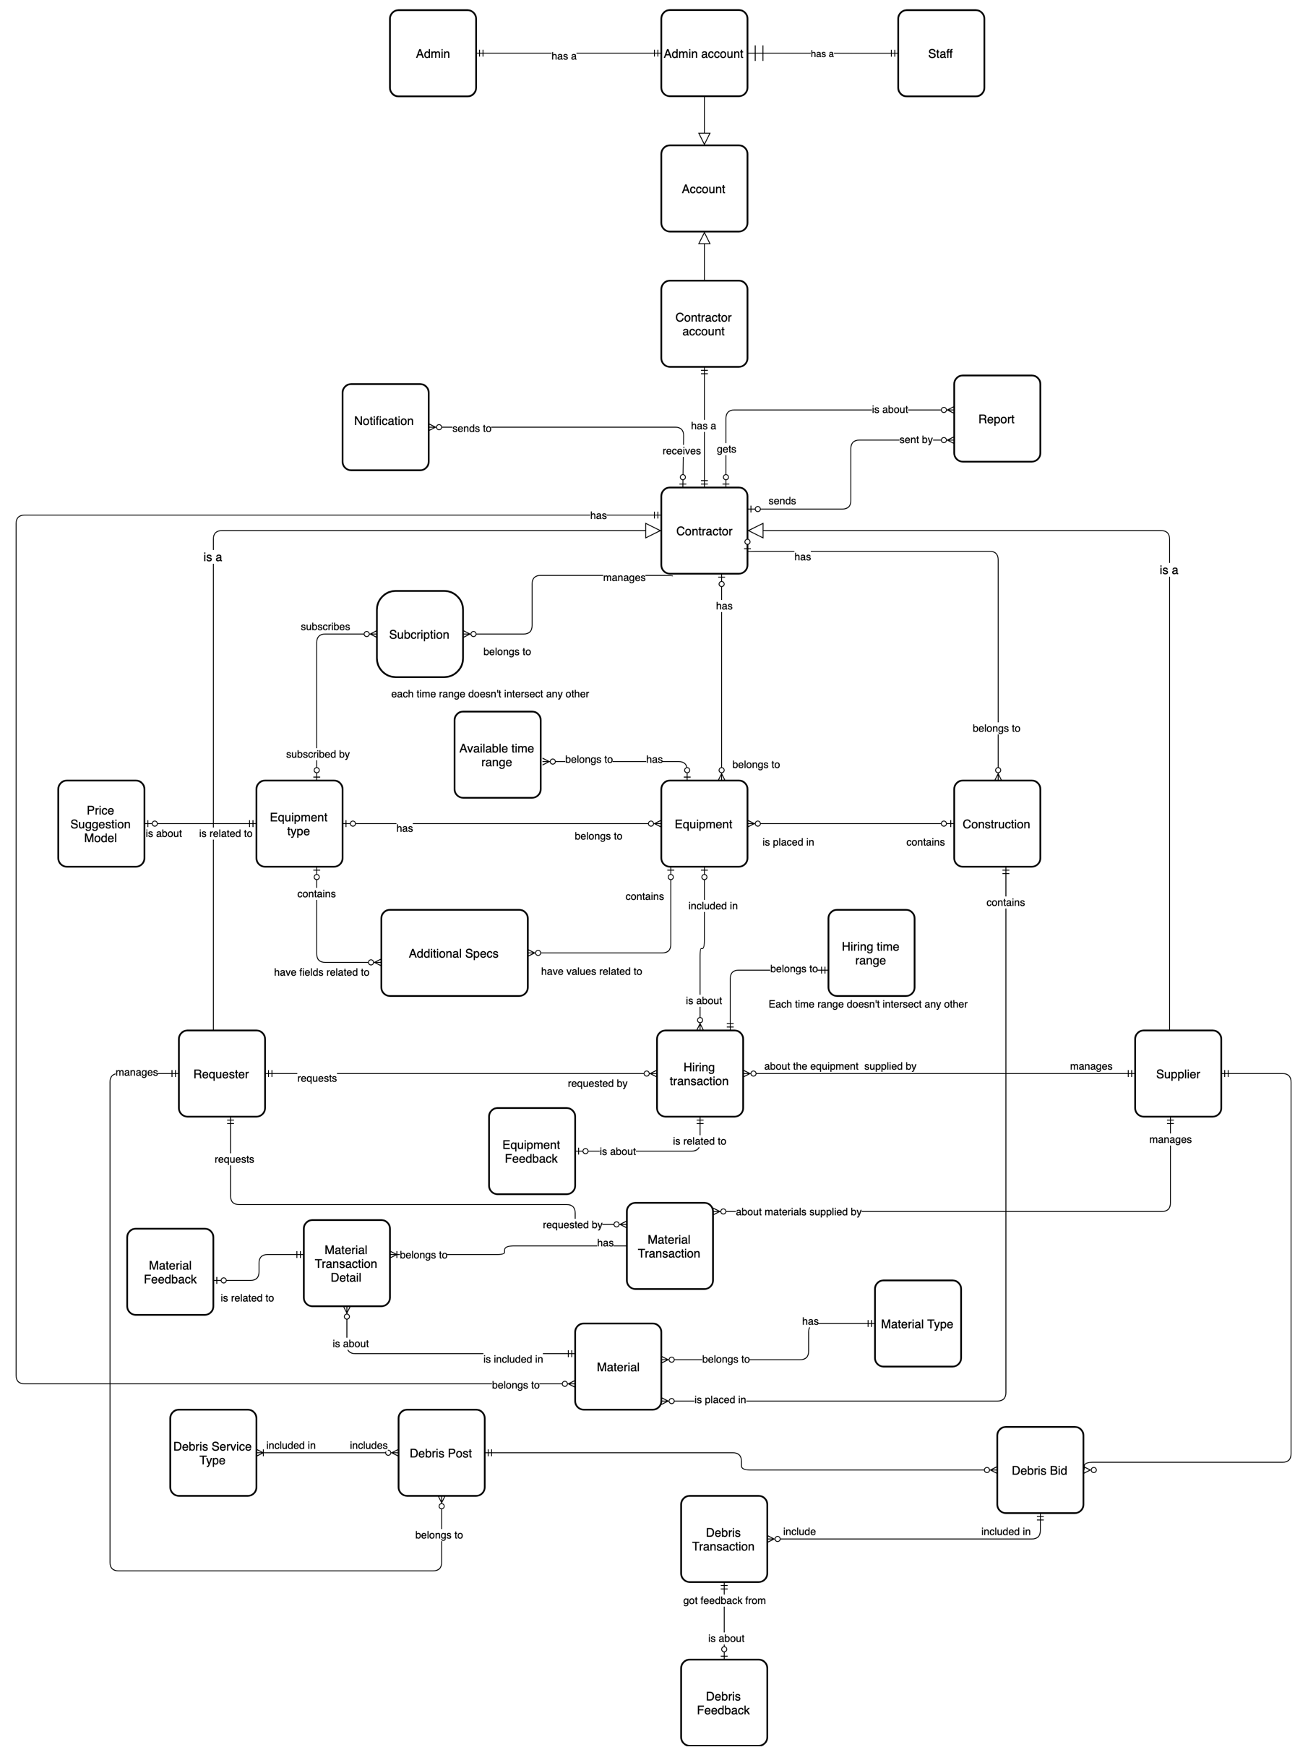

Table 12 Conceptual Diagram Dictionary

# Software Design Description

## System Architecture Design

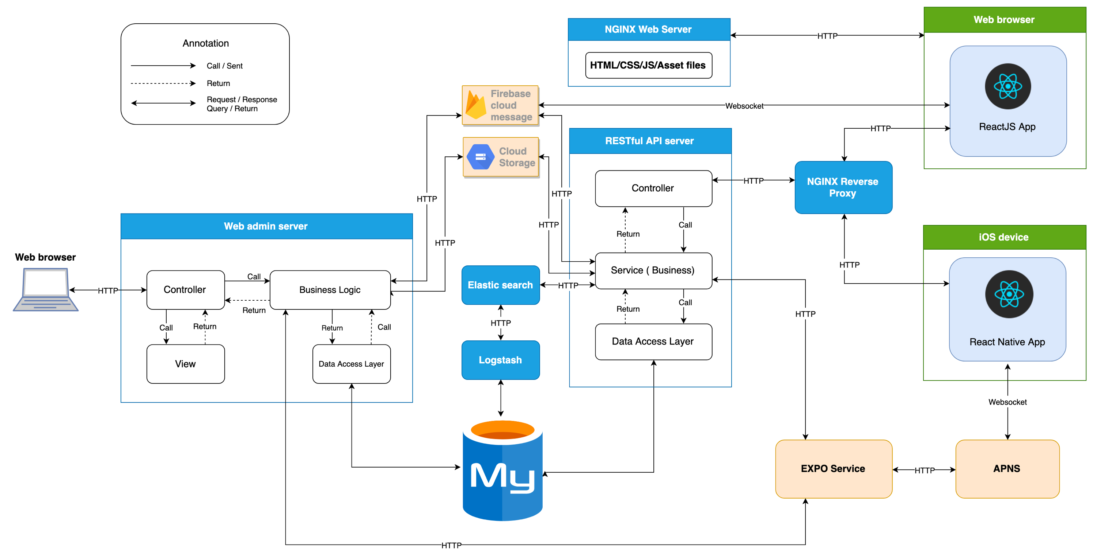

Figure 6 System Architecture

### 

### Admin web application:

In Admin Web Application, the system is developed under MVC architecture style. We choose this architecture for Admin Web Application because the following advantages:

* Quickly to develop and maintain, because the lack of human resource of our team
* Have enough flexibility and maintainability, comprehension, convention because MVC model is a classical model with variety resources and eco system.
* Save memory leaks with small amount of Javascript because of server-side rendering
* No need heavy loading in client, save computing resources for devices in offices
* Preferable for simple applications

### Contractor web system:

In Contractor web application, we choose to develop the system in Single Page Application approach because of the following advantages:

* Provide rich user interface with many features, preferable for C2C or B2C products
* Better UX/UI for end users for quick data loading and background fetching
* ReactJS is easy to master
* It is a light-weighted framework comparing to other popular ones today

In Contractor mobile application, we choose to develop the system with React Native because of the following advantages:

* Mobile app can be built with the help of Web technology which enables any web developer to easily enhance his/her skills and create React apps.
* Saves time and cost to build mobile apps on multiple platforms.
* A React Native app ensures speed and agility for the mobile apps with responsiveness and a great native app based user experience.

## Component Diagram

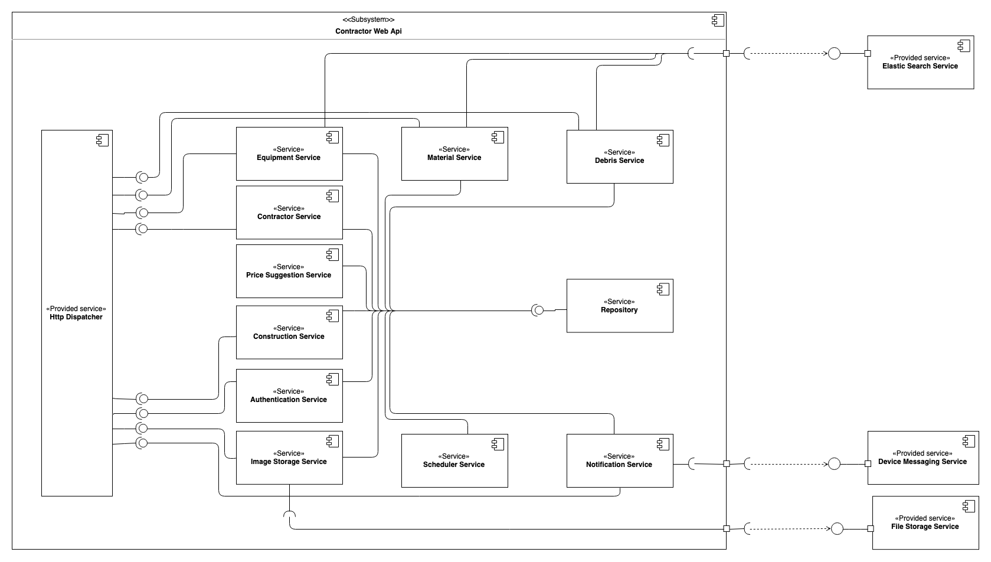

Figure 7 Component Diagram - Contractor Web Api

|  |  |
| --- | --- |
| **Component dictionary** | |
| **Component name** | **Description** |
| Equipment Service | A service responsible for managing information related to equipment, hiring transaction, hiring transaction feedbacks. |
| Material Service | A service responsible for managing information related to materials, material transactions, material transaction feedbacks. |
| Debris Service | A service responsible for managing information related to debris, debris post, debris bids, debris transactions, debris transaction feedbacks. |
| Contractor Service | A service responsible for managing information related to contractors. |
| Construction Service | A service responsible for managing information related to constructions. |
| Authentication Service | A service responsible for authentication and authorization. |
| Image Storage Service | A service responsible for uploading images, including equipment images, material images, debris images, profile images. |
| Scheduler Service | A service responsible for time-related tasks. |
| Notification Service | A service responsible for managing notification |
| Repository | A service responsible for data management. |
| Elastic Search Service | A provided service of Elastic search, responsible for low-latency performance information gathering and managing searchable resource |
| Device Messaging Service | An external service responsible for send notifications to actual devices. This service can be realized by Firebase Cloud Messaging service and Expo Messaging service. |
| File Storage Service | An external service responsible for raw resource storage. This service can be realized by Google Cloud Storage service, Imgur Storage service, etc. |
| Price Suggestion Service | A service responsible for model training, data collecting data, data processing, model applying for price suggestion. |

Figure 8 Component Data Dictionary

### Class Diagram

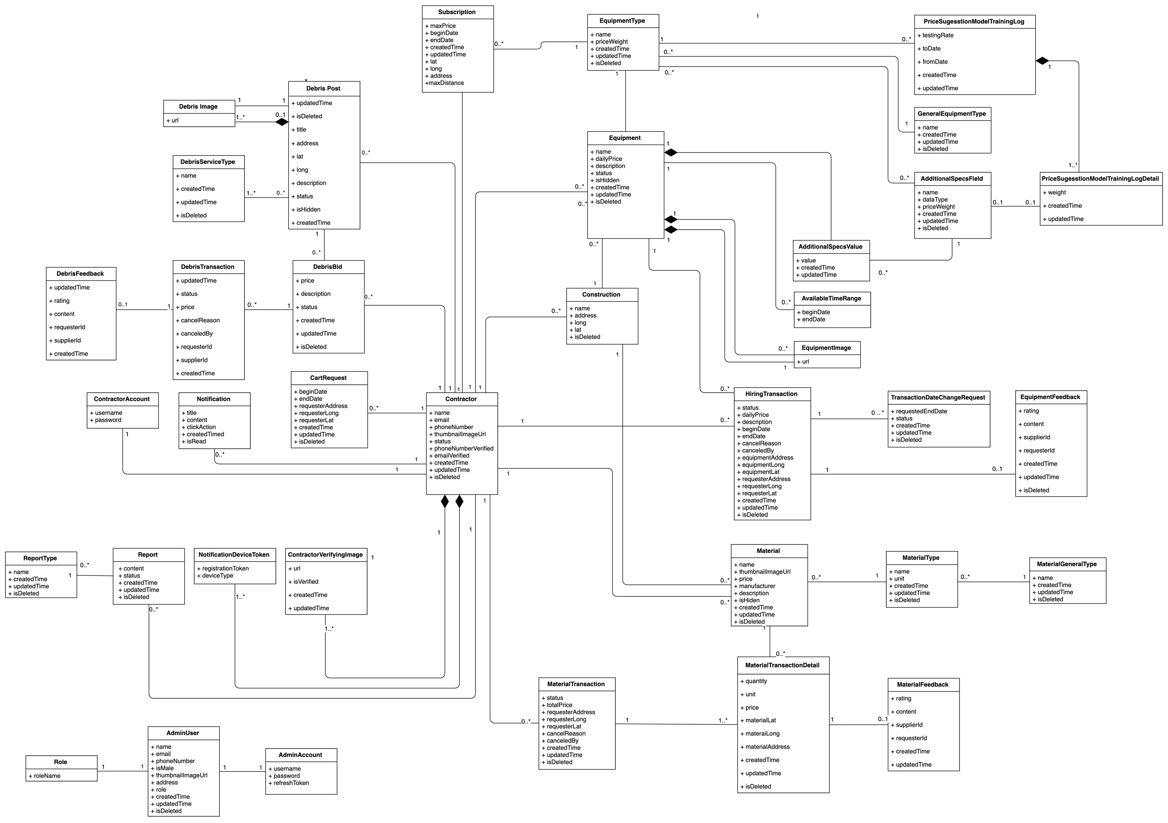

Figure 9 Class Diagram

## Interaction Diagram

### Contractor Web System

#### Post equipment

Summary:

* This diagram shows the process of Contractor posting a new equipment to the system after input required information
* Described in use case CCP_UC_31

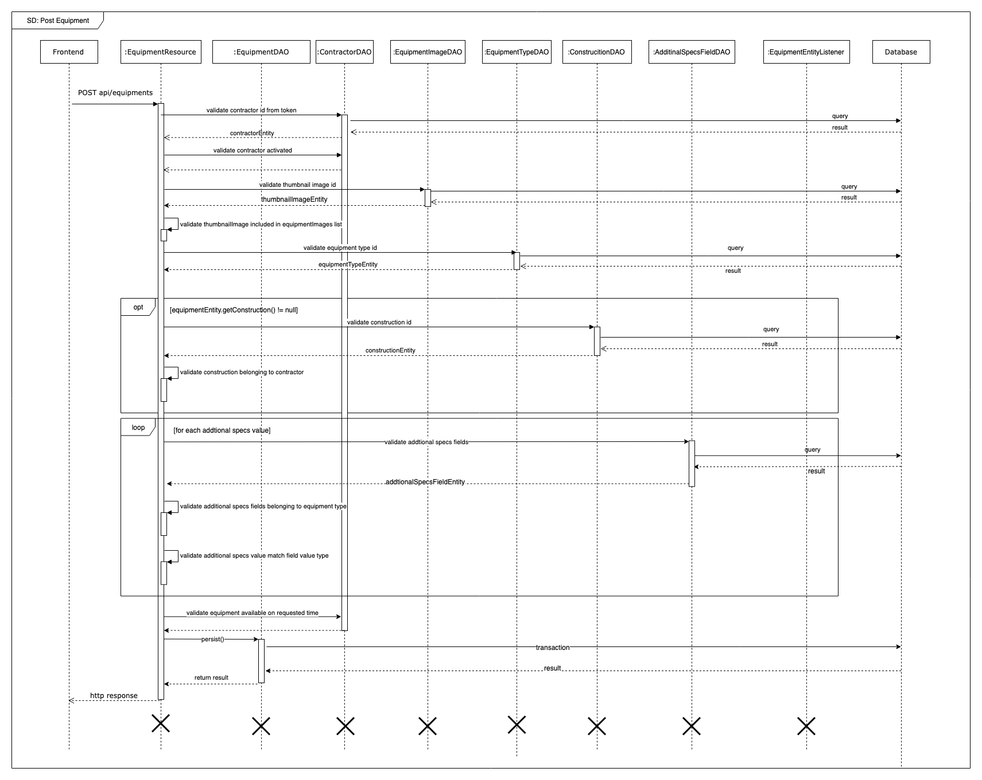

Figure 10 Sequence Diagram - Post equipment

#### Request equipment

Summary:

* This diagram shows the process of Contractor request an equipment of a supplier
* Described in use case CCP_UC_46

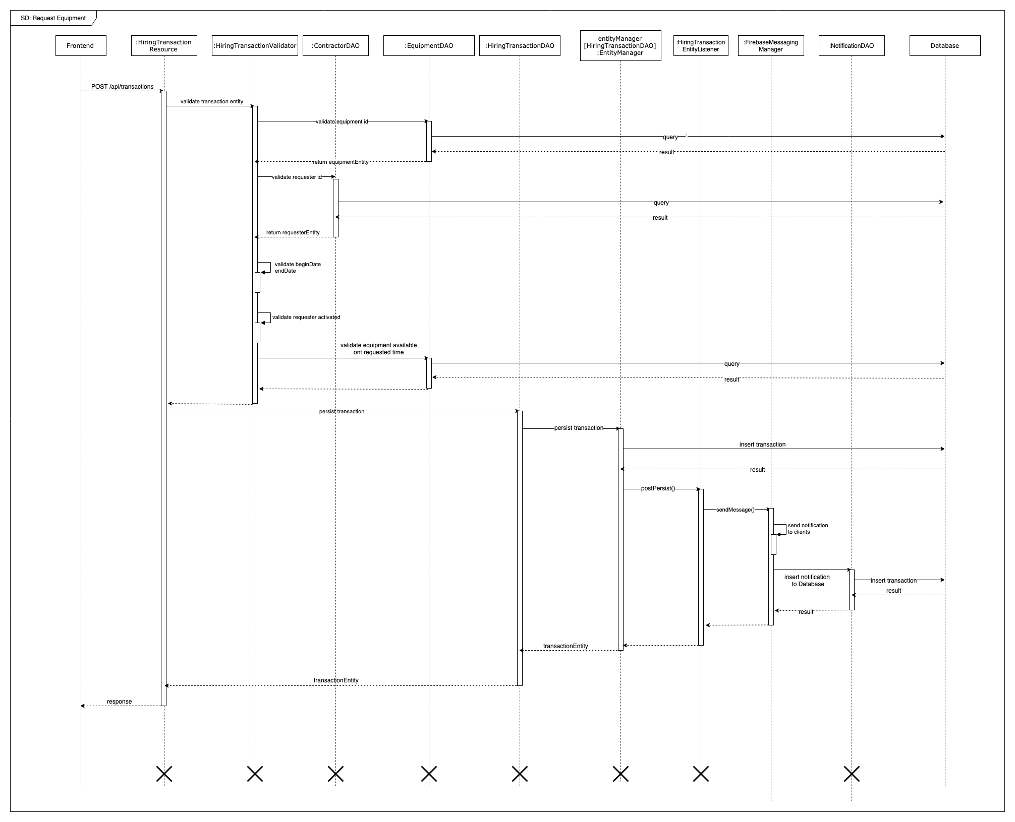

Figure 11 Sequence Diagram - Request equipment

#### Change hiring transaction status

Summary:

* This diagram shows the process of Contractor changing status of hiring transaction
* Described in use case CCP_UC_45, CCP_UC_46, CCP_UC_47, CCP_UC_50, CCP_UC_21, CCP_UC_22, CCP_UC_23, CCP_UC_24 CCP_UC_25

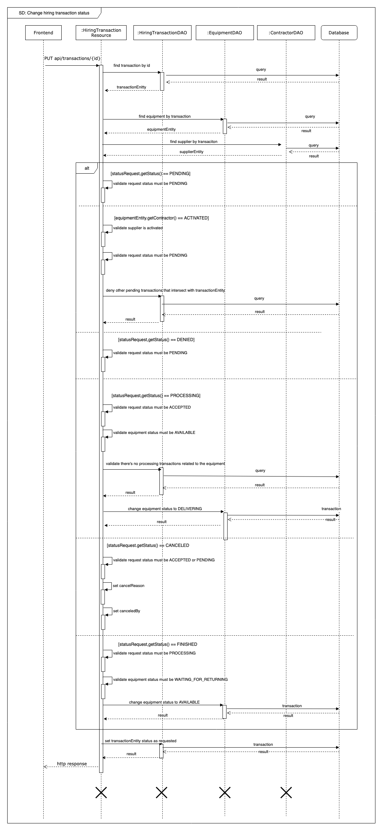

Figure Sequence Diagram - Chang hiring status

#### Checkout material

Summary:

* This diagram shows the process of Contractor checkout multiple materials from cart after providing required information
* Described in use case CCP_UC_53

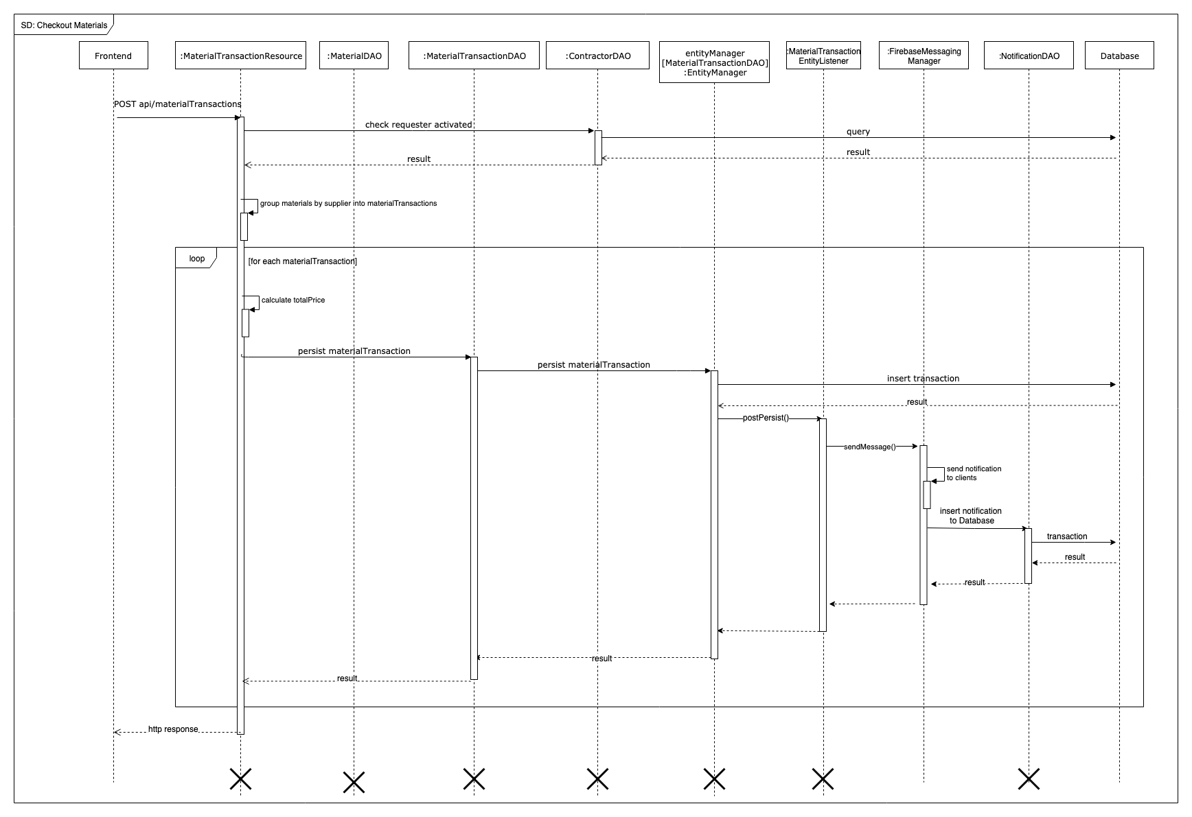

Figure 13 Sequence Diagram - Checkout Materials

#### Publish debris post

Summary:

* This diagram shows the process of Contractor publishing debris post with provided requirements to the system
* Described in use case CCP_UC_57

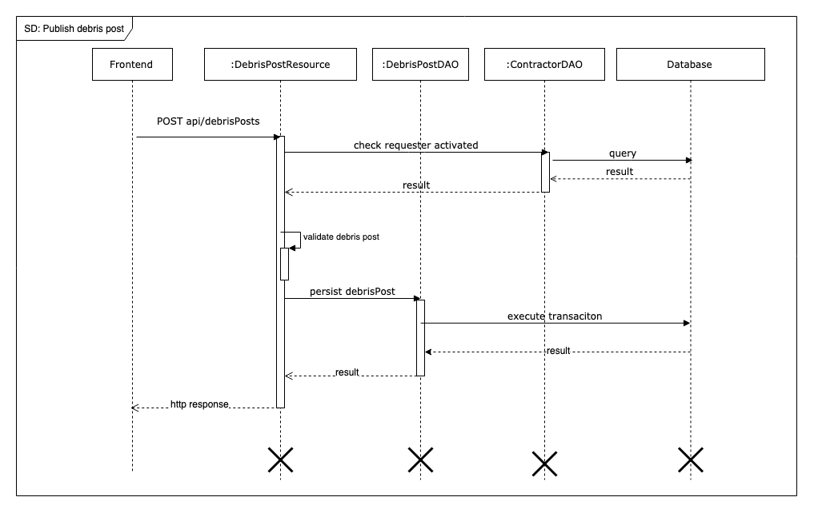

Figure 14 Sequence Diagram - Publish Debris Post

#### Bid on debris post

Summary:

* This diagram shows the process of Supplier bid on a debris post for a service offer
* Described in use case CCP_UC_40

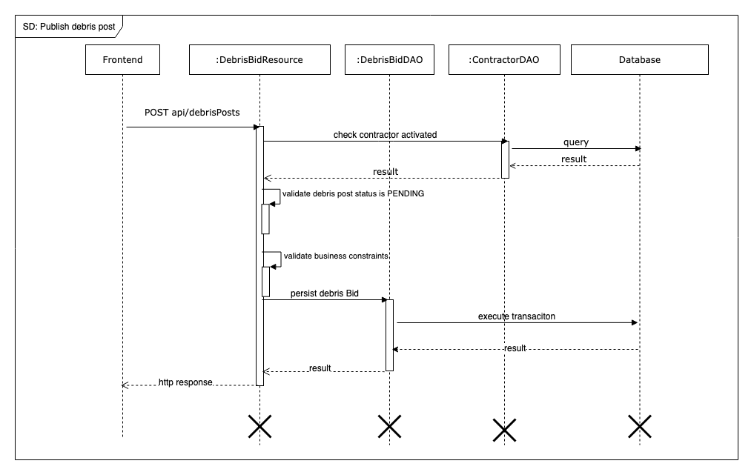

Figure 15 Sequence Diagram - Bid on Debris Post

### Mobile application

##### Rent equipment

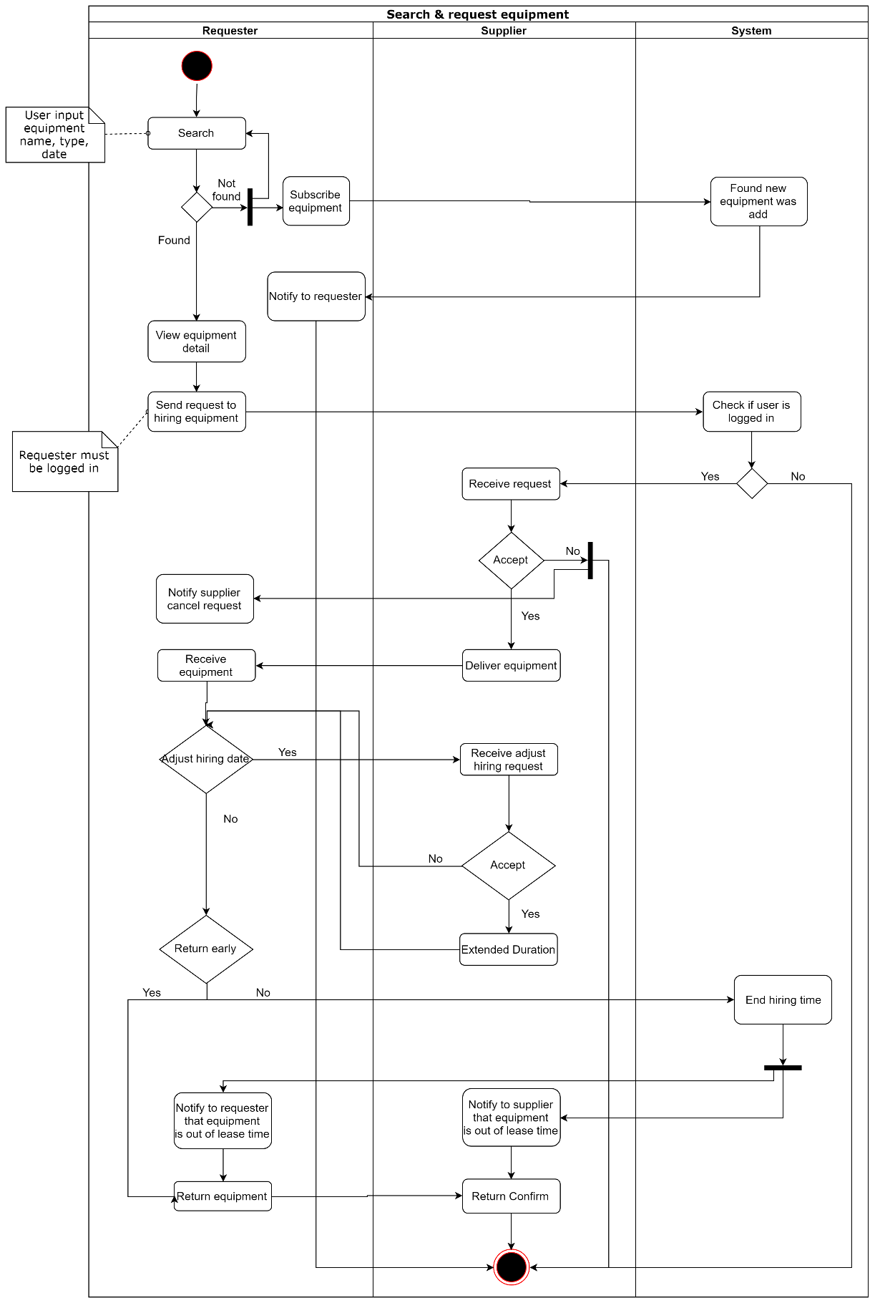

##### Buy material

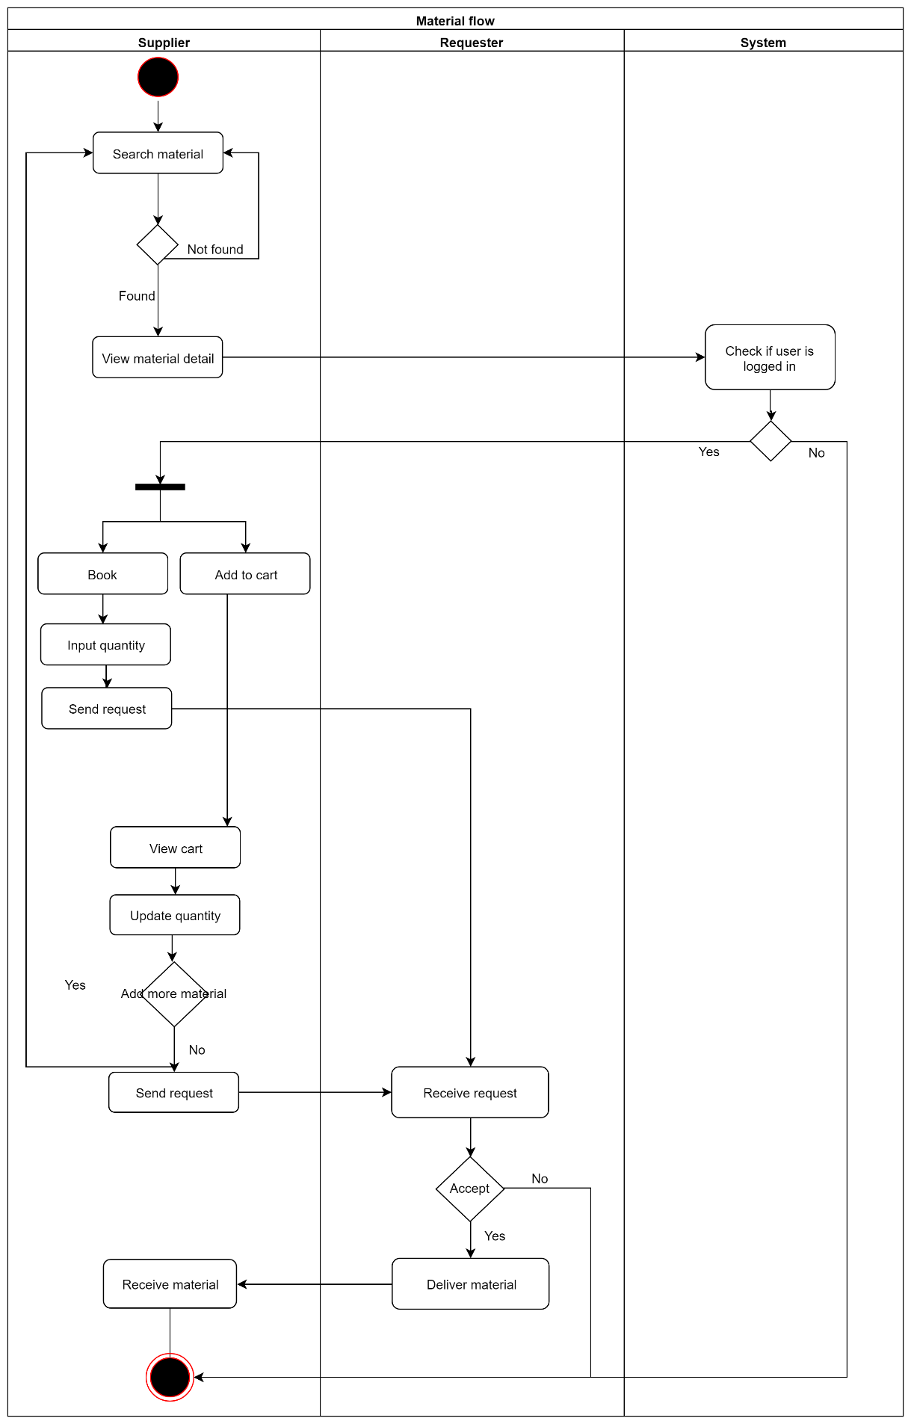

##### Bid on debris service

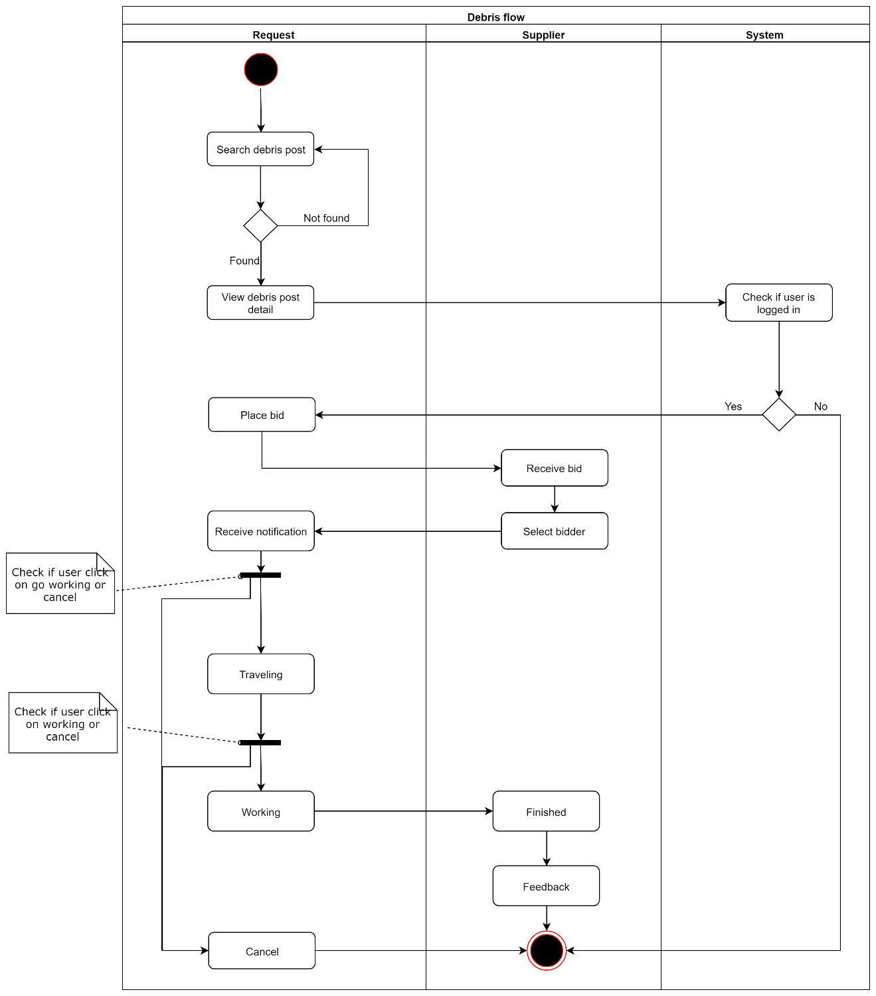

### Admin web application

#### <Staff> Verify contractor

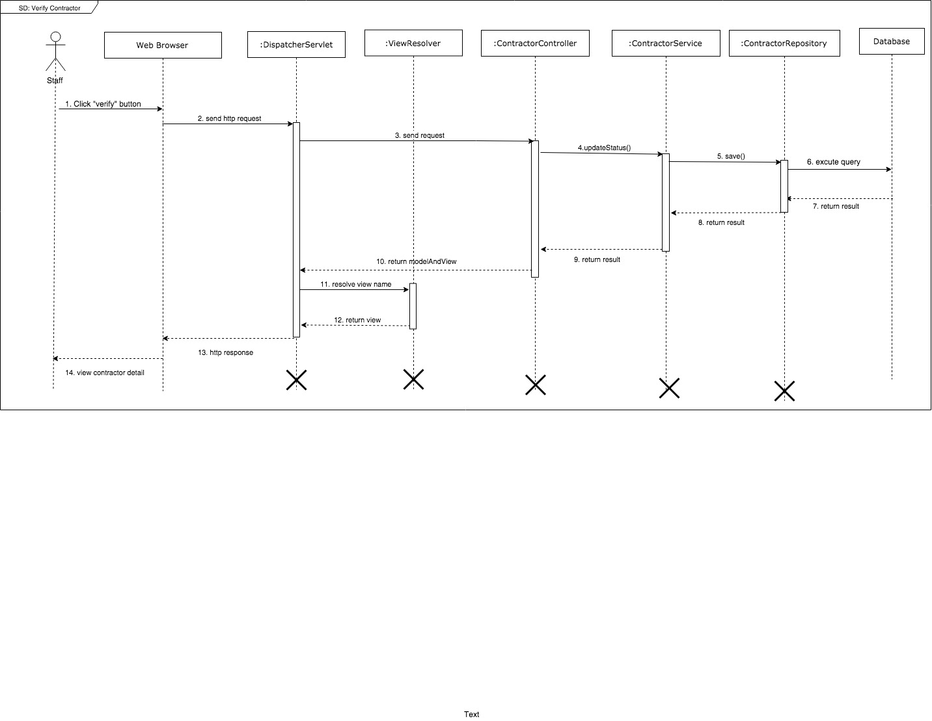

Figure 16 Verify contractor

#### <Admin> Add equipment type

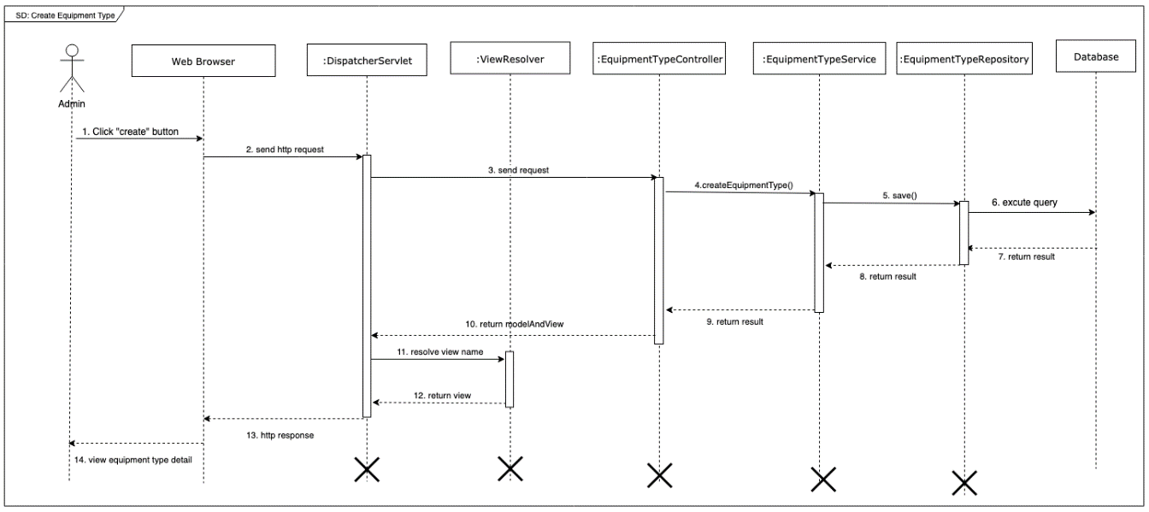

Figure 17 Add equipment type

## Database Design

### Entity Relationship Diagram (ERD)

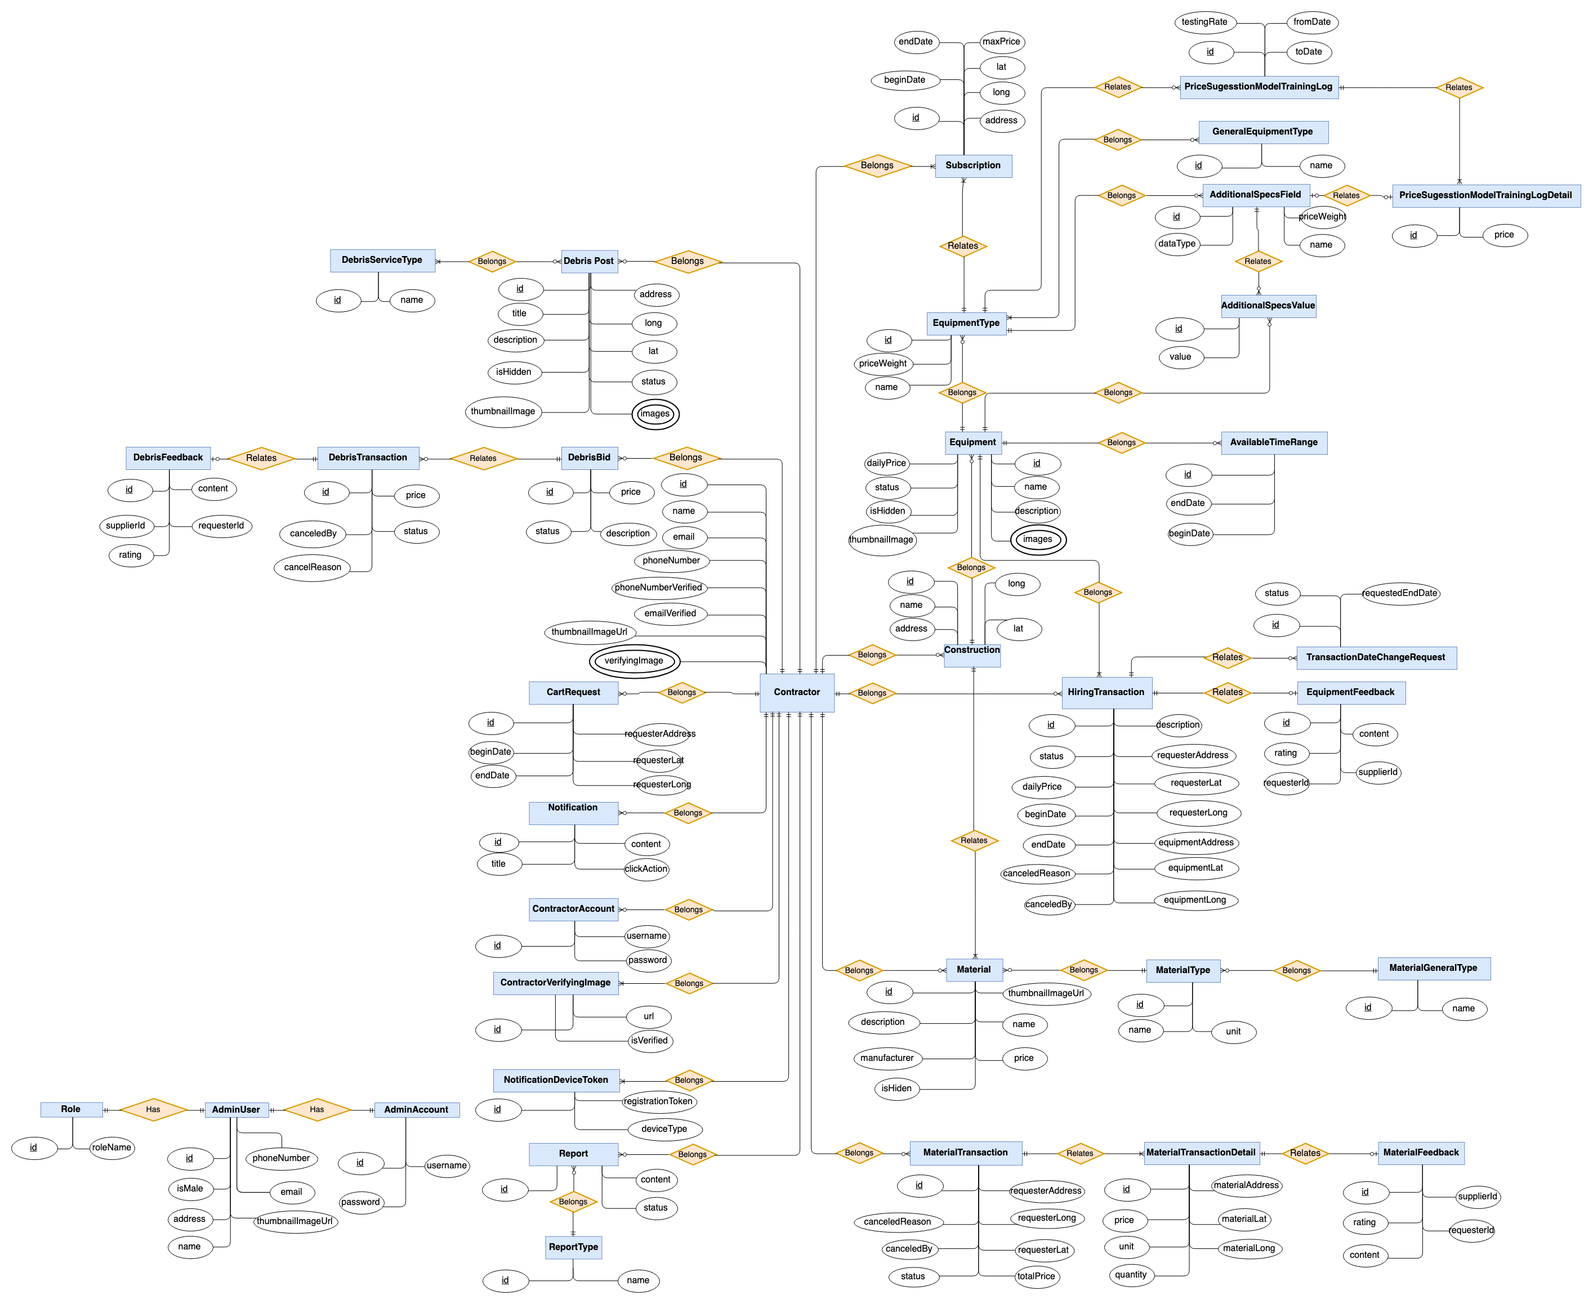

Figure 18 Entity Relation Diagram

### Data Dictionary

|  |  |
| --- | --- |
| Entity Data Dictionary: describe content of all entities | |
| **Entity Name** | **Description** |
| ContractorAccount | Contain contractor account information |
| AdditionalSpecsField | Contain additional specs fields information |
| AdditionalSpecsValue | Contain additional specs value information |
| AdminUser | Contain admin user profile information |
| AdminAccount | Contain admin account information |
| AvailableTimeRange | Contain available time range information of a equipment |
| Construction | Contain construction information |
| Contractor | Contain contractor profile information |
| Equipment | Contain equipment information |
| EquipmentType | Contain equipment type information |
| Report | Contain information of reported behavior |
| ReportType | Contain report type information |
| GeneralEquipmentType | Contain equipment category information |
| HiringTransaction | Contain hiring transaction information |
| Notification | Contain notification information |
| Subscription | Contain subscription information |
| TransactionDateChangeRequest | Contain information of hiring transaction’s date changing request |
| NotificationDeviceToken | Contain information of the token of each device for notification |
| GeneralMaterialType | Contain information of material category, which has multiple material types |
| Material | Contain material information |
| MaterialTransaction | Contain material transaction information |
| MaterialType | Contain material type information |
| DebrisBid | Contain bid information for a debris post |
| DebrisFeedback | Contain feedback information for a finished debris transaction |
| DebrisPost | Contain post information for a debris service |
| DebrisServiceType | Contain debris service type information |
| DebrisTransaction | Contain debris transaction information |
| MaterialTransactionDetail | Contain material transaction detail information |
| MaterialFeedback | Contain feedback information of a finished material transaction |
| EquipmentFeedback | Contain feedback information for a finished hiring transaction |
| ContractorVerifyingImage | Contain verifying image information |
| Role | Contain role information |
| PriceSuggestionModalTrainingLogDetail | Contain Price Suggestion Model training log detail information |
| PriceSuggestionModalTrainingLog | Contain Price Suggestion Model training log information |

Table 13 Entity Relationship Diagram Dictionary

## Algorithms

### Price suggestion model

#### Definition

Price suggestion model is a method to suggest the proper price using historical data

#### Problem

The system is expected to provide a price suggestion based on user input of a equipment information. Each equipment have different additional specifications as mentions in user requirements. Therefore, each equipment type must be provided with a different model for the most precision results

#### Solution

##### Linear regression

Linear regression can be understood as "finding the best fitting straight line for a set of data". Linear regression is used to show or predict the linear relationship between variables. Linear regression is simple and commonly used in machine learning fields.

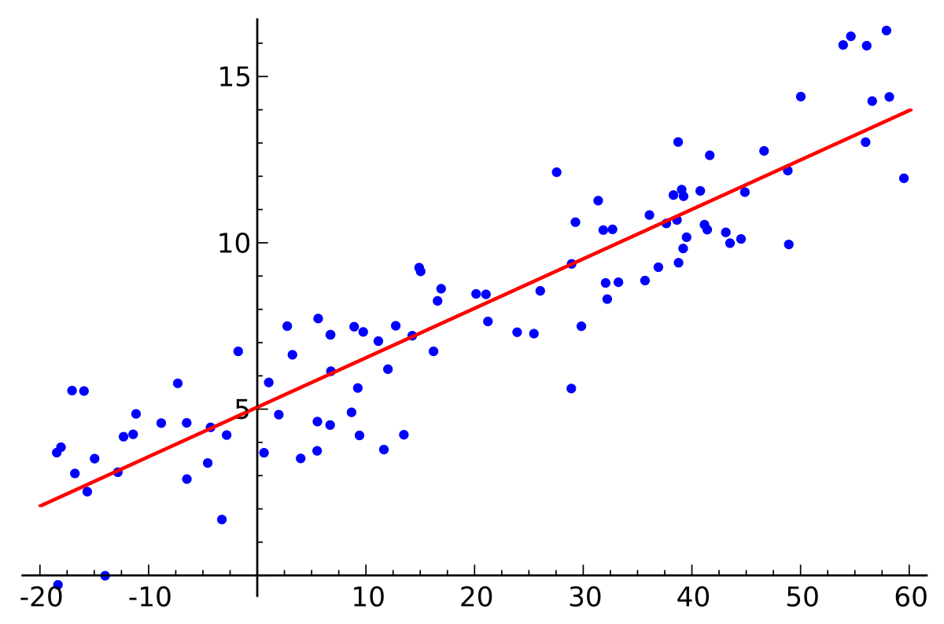

**Figure 19 Linear regression plot - from Wikipedia**

The simple form of Linear Regression can be described by the following equations:

Y= β0 + β1x

Linear regression can also applied in multi-variable related problems where there are more than 1 value of (x), like the current situation. Therefore, multi-variable Linear Regression can be represented by the following equation:

$$f(X)=X.θ$$

In above equation:

X:  Input feature value of each instance. ( matrix mxn)

θ: hypothesis parameters (co-efficient) of the model (vector (nx1))

with:

m: number of samples or dataset

n: number of features of the model

Linear regression has the following benefits:

* Benefits
* Simple
  + Fast to train
  + Can used for multiple-variable problems (more than 1 variable)
  + Works in most cases
* Trade-offs:
  + Validation rate is not high because not all variable relationships are purely linear
  + Sensitive to noise (outliers)

##### Cost function for linear regression:

A cost function is a function that tell us "how good" our model is. For linear regression, one of the most commonly used cost function is Least Squared Error function:

$$E=\frac{1}{2m}\sum_{i=1}^{m}{{(h_{θ}\left(x^{\left(i\right)}\right)-y^{\left(i\right)}))}^{2}}$$

With $h_{θ}\left(x^{\left(i\right)}\right)$  
**:**prediction result

$y^{\left(i\right)}$**:** actual price

**m:** number of samples used to train

**The smaller the cost function, the better the model is**

##### Training approach with linear regression

To train a machine learning model with linear regression, there are 2 available approaches:

* 1. **Gradient descent**

Gradient descent is an optimization algorithm used to minimize the cost function by iteratively moving a point toward its local minimum point. In machine learning, we use gradient descent to update the weights of our model.

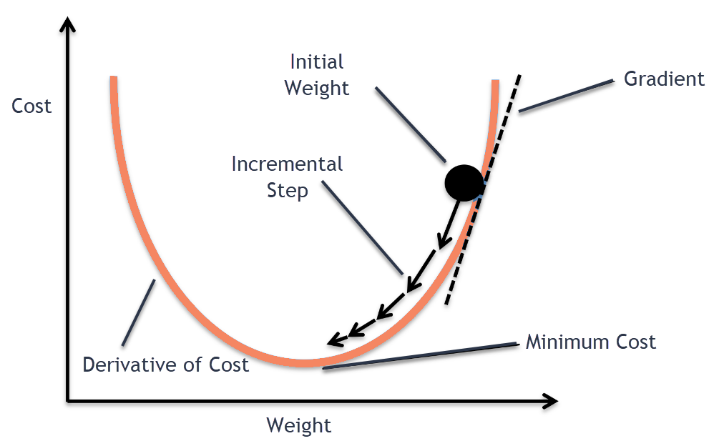

**Figure 20 Gradient Descent Plot**

Gradient descent allows us to set up hyper-parameters before training process, including number of iterations, initial weights, learning rates. Therefore, Gradient descent is highly customizable and stable with noise and outliers.

Gradient descent haves the following benefits and trade-offs:

* Benefits:
  + Can manually adjust model result by setting the number of iteration loops
  + Can endure noise thanks to high customizability
* Trade off:
  + Slow because of the iteration needed for training
  + Require initial parameters
  + Need many manual run to figure out the best result
  1. **Normal equation**

Normal Equation is an analytical approach to directly calculate the model weight θ without using Gradient Descent. The normal equation can be described as the following:

$$θ={(X^{T}X)}^{-1}. (X^{T}Y)$$

In the above equation,

**θ** : hypothesis parameters that define it the best. (vector nx1)

**X** : Input feature value of each instance. ( matrix mxn)

**Y** : Output value of each instance. ( vector mx1)

with :

**m**: number of samples or dataset

**n**: number of features of the model

Normal equation is inferred by applying derivative on the cost function, which is Least Squared Error function to find the local minimums. Because of the characteristic of the squared function, the local minimum is also the global minimums, which is our desired final result. Because the final hypothesis parameters is calculated directly with 1 step, the hypothesis is very fast. However, because there are no manually tuning and setting involved, Normal Equation approach can easily affected by noise and outliers in the dataset.

Using normal equation would also have benefits and trade-offs:

* Benefits:
  + Fast with 1-step learning
  + No related initial settings needed
* Trade-offs:
  + Cannot manually adjusted, so it is very sensible to noise

##### Implementation

We choose to use **normal equations** approach instead of **gradient descent** because:

* Faster
* Because of the project scope, there would be no human involved

For each equipment type, we would train a separate model

$$θ={(X^{T}X)}^{-1}. (X^{T}Y)$$

Input:

* X: additional specs values of all the equipments of the equipment type
* Y: price of the equipments

Output:

* $θ$: hypothesis parameters of the model

Hypothesis parameters would be used to calculate suggested price by linear regression equation:

$$f(X)=X.θ$$

With:

* **X**: input values of the equipment need to suggest price
* $θ:$ hypothesis parameters of the model
* $f(X)$: suggested price

## Physical Diagram

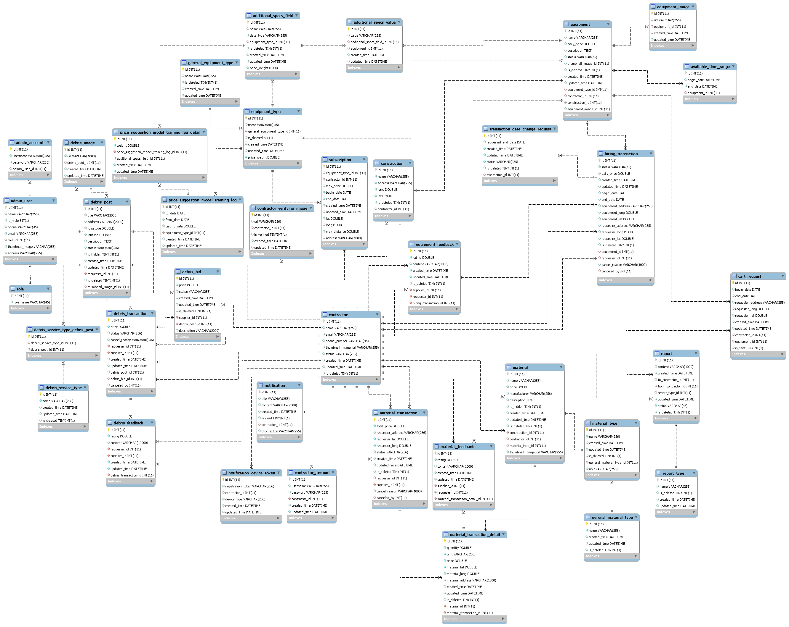

Figure 21 PhysicalDiagram

## Future Plans

* Current system can only support admin to manage equipment. We design the system to provide analytic views for admin:
  + Admin can view statistics and visualized graph about transaction process
  + Admin can view strategic information about equipment trends, hiring trends, contractor needs trends
* Current system can only suggest price to contractor based on equipment type. We design the system to support data for further machine learning features:
  + Suggest equipment price based on equipment name, location, time
* Current system can only provide delivery status to delivery management. We design the system to support more feature to delivery phase:
  + Support direction and route guidance for delivery
  + Support delivery time estimate based on city, time, traffic